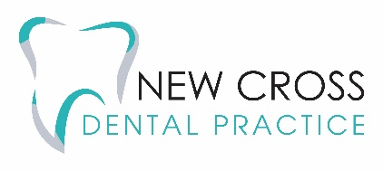
NHS APPOINTMENTS AT NEW CROSS DENTAL PRACTICE
If you are not currently registered with our practice either NHS or independently, we are trying to make provisions for those who need and want to access NHS dental services as best as we can.
Please provide the requested information so we can make an arrangement for you to be seen at the practice as soon as we have availability.
If you are experiencing an emergency, we will try and provide emergency care at the appointment but please note you may need additional appointments to completely resolve your issue so the first visit may only be just an assessment.
Please note being seen at the practice for your emergency will not constitute registration and you will need to wait to be seen for definitive treatment once we have availability.
Please attach any photos and any previous x-rays you may have which you can request from your previous dentist which will help the triaging dentist. This will enable us to triage you quicker and you are more likely to be seen sooner should you supplement your form with this additional information.

Please note ALL sections must be filled in and answered otherwise we will not be able to assess your case for triage or assessment by one of the dentists.

The reception team at New Cross Dental Practice will be in touch to book you in for an appointment for your emergency or your routine examination the moment availability for a new NHS appointment becomes available.

Please email the completed form and any relevant xrays to reception@newcrossdentalpractice.co.uk

Personal Details
*Name:
*Address:
*DOB:
*Email address:
*Telephone Number:
*NHS number:
*Last dental visit:
If you are simply requesting a routine NHS appointment and are not experiencing any issues then you don’t need to fill in the rest
Pain History
1. Where is the pain?
2. When did the pain start? For example, was it sudden or gradual?
3. What is the pain like? For example, is it a short, sharp pain or a long, dull ache?
4. Any other signs or symptoms associated with the pain? For example, pain on biting, sensitivity to hot or cold, facial swelling or difficulty in breathing?
5. Does anything make the pain better or worse?
6. How bad is the pain on a scale of 1 to 10 (1 – minimal pain, 10 – maximum pain)?
7. Have you had any dental treatment in the same site of the pain within the last 18months? Or has a dentist examined you within the last 2 years whether it be routine or for an emergency?

